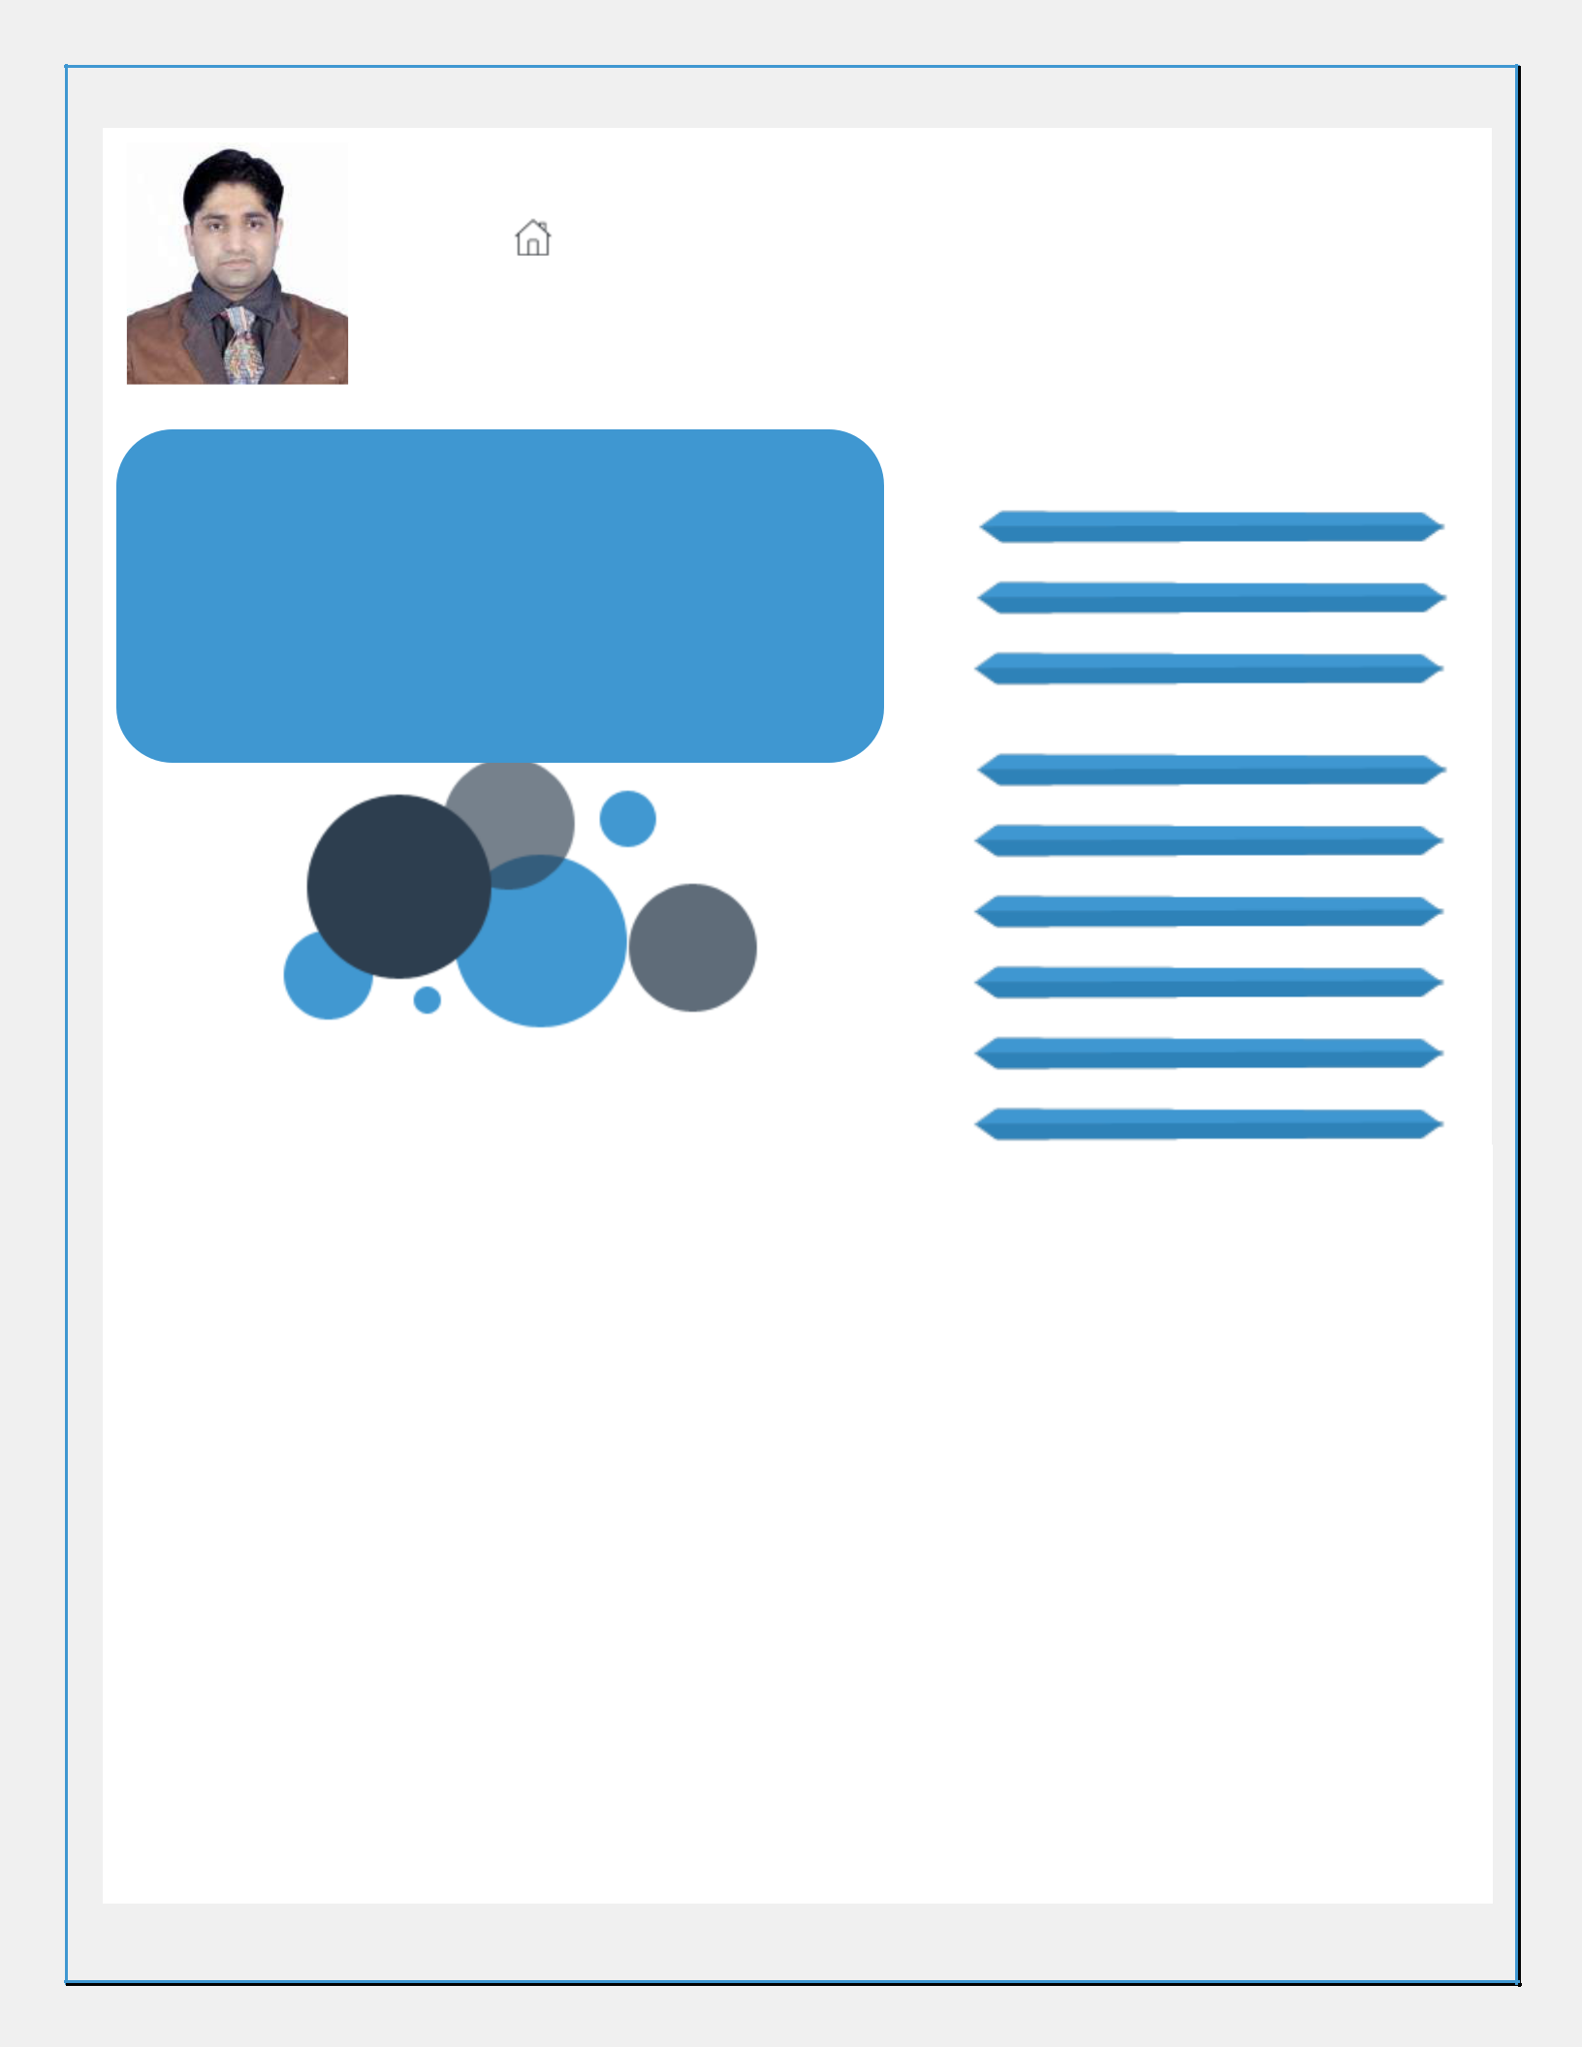
Phone: 91-9560102391
E mail: kapilgupta.pt@gmail.com

Address: 131, JP Nagar, Phase 7, Bengaluru

KAPIL GUPTA |  |  | Core Competencies
CLOUD ARCHITECT | PROJECT MANAGEMENT |  |  | Cloud Deployment, Configuration /
 |  |  | Integration (Private/Public)
A multi-faceted professional, excels at coordinating with
cross-functional teams; skilled in adopting a pragmatic |  |  | Telco Cloud Architecture
approach in improvising on solutions and resolving
complex business issues; targeting assignment in Solution |  |  | Project Implementation & Roll-outs
Architecture in Telecom/IT industry, preferably in
Bengaluru/Delhi NCR |  |  | Technical Architecture/Cloud Operations
Soft Skills |  |  | Technical Architecture/Cloud Operations
Soft Skills |  |  | using DevOps & SRE Approach
Motivator |  |  | Solution Designing
Collaborator |  |  | Technology Transformation & Integration
Change
Agent | Planner |  | Dashboard Design & Development
Vendor Management

Logic Building

Executive Profile

- High-energy, focused, IT professional with nearly 10 years of experience in Telco Cloud solution design, planning, operation automation, deployment, and installation Cloud Platforms like OpenStack and VMware & Kubernetes containers

- Forward-focused Solutions Architect with expertise in concepts of end-to-end project planning & implementation from scope management, to activity sequencing, effort & cost estimation, risk analysis to quality management in coordination with the business & stakeholders

- Pivotal in managing project coordination activities entailing planning, scheduling, application maintenance & enhancement. Proficient in end-to-end testing of software products from requirement analysis to system study, designing, testing, documentation

- Skills in designing and architecting Telco Cloud with a special focus on NFV/SDN and Cloud. Managing multiple NFVi silo deployment for vEPC, BvCPE, RvCPE, vIMS and also building and managing horizontal NFVi cloud for all types of telco VNF workloads, which building with Cisco OpenStack, and multiple OpenSoruce based FCAPS tools.

- Conducted detail discovery, design, demo workshops with vendors. Design and develop end-to-end solutions and reference architectures, HLD, LLD comprised of leading-edge virtualization, networking (including Software-Defined Networking), Software Defined Network & Containerization.

- Worked with different vendors to estimate effort and develop the project plan to meet management expectations and ensure successful solution and project delivery

- Exemplary in integration & configuration of a wide range of equipment with sound knowledge of technologies, designing customer networks & analyzing information system needs, evaluating end-user requirements, custom designing solutions, troubleshooting for complex information systems management

- Pivotal in practicing DevOps model to ensure day to day operation and planning and development for Telco cloud.
- Adept in NFV and SDN products, technologies, architectures, ETSI standards and vendors.
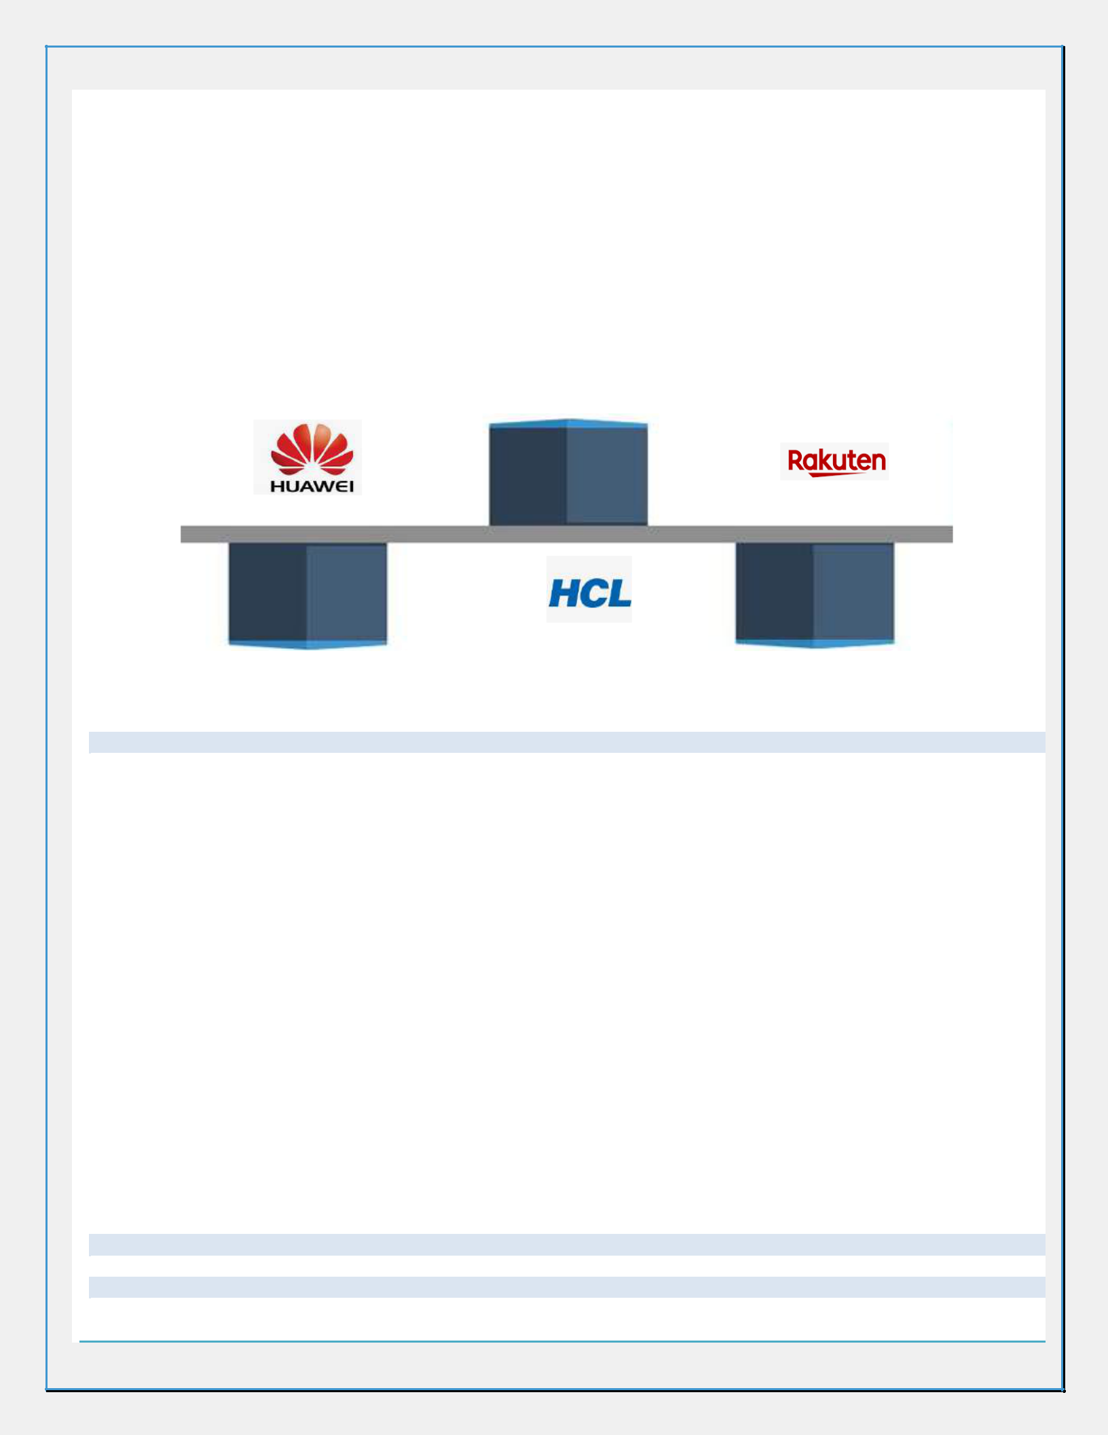
- Expertise in designing virtualized compute environments like VMware, OpenStack, docker, Kubernets

- Led large-scale business application architecture and design efforts; developed and maintained application architectures for various business functional areas; resolved integration and interface issues between various applications or systems with focus on optimizing application performance and scalability

- Skills in monitoring (NFVi KPI & DashBoard design & FCAPs)| Automation| Installation & Deployment | OpenStack(Cisco CVIM, VMware Integrated OpenStack)/ Kubernetes | Python | ONAP/Cloudify

- Worked on Multi-cloud Project of ONAP to setting up Windriver OpenStack and VIO labs
- Skills in designing dashboard for Physical and logical Inventory in OSS & Telco Cloud Infrastructure in OSS

- Managed & ensured project deliveries in a timely manner involving seamless onsite/ offshore coordination and transparent communication with all stakeholders at all phases

- Proven success in suggesting appropriate as well as technology-based solutions for enhancing functional efficiency of the organization and achieving business excellence

Career Timeline

 | Technical | Solut
 | Lead/Solutio
 | n Architect | ion Architect
Oct’15-Mar’16 | Apr’16-Dec’18 | Since Dec’18
Deputy |  | Technical
Manager |  | Lead/Solutio
 | BS | n Architect
 | S Consultant

Professional Experience

Since Dec’18 with Rakuten India (Rakuten Mobile Department), Bengaluru as Technical Lead/Solution Architect Key Result Areas:

- Acting as Cloud Architects for Application, Data, Infrastructure (Tech. Arch.), Integration, Performance & Development (Tools) Architects; devising and/or designing and architecting solutions

- Specifying roadmap, technology transformation requirements, productivity improvement, and competency development

- On-boarding VNFs on to NFV Orchestrators. ( ONAP, Cloudify )
- Deploying configuration management tools such as Ansible
- Working different server hardware like Quanta, HPE, DELL, Quanta, Cisco, IBM
- Designing & implementing Vmware/Openstack based platforms for various telecom nodes
- Driving & designing large enterprise solutions specifically in areas of legacy modernization & transformation to cloud

- Facilitating IT software solutions / application development initiatives involving mapping of business requirements and in-depth evaluation of customer feedback to execute modifications in the solution

- Mapping clients’ requirements, attending / conducting business user meetings, driving solution & technical architecture plans and providing them customized business solutions

- Delivering regular health check of the solutions offered and ensuring that solutions, technical & services meet or exceed organization / industry quality standards and end user requirements

- Interacting with team members to ensure smooth progress of defined solution; ensuring adherence to quality norms throughout the implementation process

- Steering resource planning, SOW, technical direction, effort estimation, tracking, risk management & mentoring
- Providing post-implementation, maintenance and enhancement support to the client with regards to the solution
- Working as a member of the Central Technology Services Group in the organization

Apr’16-Dec’18 with HCL Technologies Limited (ERS), Noida as Technical Lead/Solution Architect Oct’15-Mar’16 with Huawei Technologies, Gurgaon as Deputy Manager

Jul’13-Oct’15 with Ericsson Global India limited, Noida as 2LA/ Customer support Engineer

Aug’11-Jul’13 with Nokia Siemens Networks, Lucknow as NSS Configuration Engineer

Oct’09-Aug’11 with Ericsson Off Role (Essjay Ericsson and TICS), location as Ericsson Off Role (Essjay Ericsson and

TICS)

Knowledge Purview

- 2G/3G/4G(IMS-VOLTE)/5G mobility
- Cloud-native microservice-based architecture for NFVi
- ETSI NFV Architecture
- OVS, SRIOV, DPDK networking and numa awareness, CPU pinning, Huge page
- Monitoring and logging architecture using ELK stack and Prometheus, Telegraf, Grafana, Node_exporter, IPMI
- NFVi Performance benchmarking comparison OVS, SRIOV, OVS-DPDK
- Virtualization, hypervisor (KVM, ESXi/vCenter)
- NFVi KPI for multiple Telco DCs (Centralise and Edge )
- Documenting LLD and HLD review and other operational MOP, design and configuration guide for NFVi

- POCs design for ONPA deployment on VMware Kubernetes, VMware Integration OpenStack upgrade
- ONAP (Open Network Automation Platform) Amsterdam release on VMware integrated OpenStack (VIO)
- SRE approach for SLA, SLI, SLO, error budget
- DevOps, CI/CD pipeline using Jenkins, Ansible
- Python scripting and exposer in Ansible
- OpenStack Rest-api’s (Ceilometer, nova, neutron)
- Object-Oriented Programming - OOPS concepts using Python
- Routing, switching, IPv4, and IPv6
- ETSI NFV Architecture and member of ETSi NFVi community

- ONPA deployment on VMware Kubernetes , VMware Integration OpenStack upgrade without impact the running VNF services, MetaSwitch VNF deployment using cloudify

Trainings

- RedHat OpenStack training 110,210, 310 and 125 and Udemy

- RedHat OpenShift and Kubernetes D180
- RedHat Ansible automation
- Python training from HCL and Udemy
- VMware vCenter, NSX and VIO from HCL
- Kubernetes administration from Udemy

Technical Skills

Cloud Platform: OpenStack (Cisco CVIM, VMware VIO, RedHat, Vanilla OpenStack ), OpenStack Helm, OpenStack Kolla-ansible, VMware (vCenter, NSX, VIO)

Hypervisor: ESXi and KVM

Containers: Docker containers and Kubernetes

Orchestration: ONAP, Cloudify, Heat

Python Libraries: Pexpect, Popen, OS, Json, YAML, IPaddress, netaddr, OpenStack Rest API

Operating System: Windows XP/Vista/7, Linux (Ubuntu 16.04, Centos, RedHAT)

Languages: Python, Ansible, YAML( OpenStack Heat, Cloudify blueprint )

Networking: Basic IP networking

Telco: Volte, IMS, CS Core, 2G/3G/4G/5G SIP, ISUP, BICC, H.248, GSM, MSS/MGW, CSCF, SBC, TAS

Education & Credentials

B.Tech. (Electronics & Communications) from Rajasthan University in 2009

Personal Details

Date of Birth: 2nd May 1986| Languages Known: Please mention

~Refer Annexure for Major Projects~

ANNEXURE

Project: Telco Cloud Monitoring Architecture Design For NFVi
Company: Rakuten

Technologies: Cisco CVIM OpenStack, Open NFV, CVIM and OpenStack rest API’s, Prometheus, Node_exporter, IPMI exopter, Telegraf, Quanta servers, SNMP

Period: Since Dec’18
Role: Architect/Project Lead for NFVi monitoring and KPI

Brief: This project monitored architectures design finalization for NFVi

Key Results Areas:
- Define and finalize KPI’s and threshold with coordinating with multiple teams
- Update NFVi monitoring architecture from each OpenStack VIM to centralize monitoring design for ALL VIM
- Build logic for near real time monitoring of KPI
- Integration with OSS, Alarm life cycle like alarm generation, clear, resync, co-relation
- Identify missing alerts for hardware errors. Define and developed new IPMI sensor for them

Project: Telco BareMetal Server Monitoring Architecture Design
Company: Rakuten

Technologies: BareMetal Servers, Prometheus, Node_Exporter, IPMI_exopter, Telegraf, Quanta Servers, SNMP
Period: Since Dec’18
Role: Architect/Project Lead

Brief: This project monitored architectures design finalization for BareMetal Server

Key Results Areas:

- Using Open source Prometheus, Node_exporter, IPMI_exporter and SNMP for building Observability framework and monitoring BareMetal Servers
- Defining KPI and alerts for BareMetal server

- Collecting the requirement for monitoring for BM servers with different BM servers owners/vendors
- Resolving issue for IPv4 and some non-installable server to connect alerts with SNMP
- Integrating BareMetal with OSS, Alarm life cycle like alarm generation, clear, resync, co-relation

Project: Infrastructure inventory dashboard design
Company: Rakuten

Technologies: CVIM, CVMON, OpenStack, Inventory
Period: Since Dec’18
Role: Architect/Project Lead

Brief:

This project focused at designing infrastructure dashboard to display near real time metrics/KPI and included physical and logical inventory
Key Results Areas:

- Creating infrastructure dashboard design to CTO
- Collecting required API to design this dashboard and explain the logic to development team
- Defining logic to manage large data to display NFVi KPI’s metrics with near real time

Project: Executive Dashboard Design

Company: Rakuten
Technologies: CVIM, CVMON, OpenStack, NFVi, SRE
Period: Since Dec’18

Role: Architect/Project Lead

Brief:

This project is focused at designing executive dashboard to display near real time network utilization, critical issue, thresholds using Site reliability approach and define error budget.

Highlights:
- Defined SLI/SLO for the selected metrics to measure capacity and availability of cloud infra
- Define Error budget policies for the metrics.

Project: Proof of Concept(POC) to Deploy Metaswitch vIMS Using Cloudify And Scale If Test Cases
Company: HCL Technologies (ERS)

Client: Telia
Technologies: VIO, KVM, Cloudify, MetaSwitch vIMS VNF
Period: Mar’18-Dec’18

Role: Technical lead

Brief:
This project was a POC for deploying clearwater IMS VNF using cloudify on openstack and demo of live call using sip client
Highlights:

- Resolved cloudify blueprint issue for vIMS VNF
- Worked with VNF owner to Fix Volte configuration issue
- Registered sip client, UE and conducted end-to-end volte call
- Conducted test auto scaling

- Created python scripts for auto scaling if cases. like In Multi OpenStack VIM, to calculate resources for the tenant and allow VNF onboarding only for the tenant having enough space

Project: ONAP Deployment Integration With VMware Integrated OpenStack & Kubernetes and Create Firewall VNF Onboarding Demo And Multi Cloud VNF Onboarding Demo With Windriver

Company: HCL Technologies (ERS)

Client: VMware
Technologies: OpenStack, VMware Integrated OpenStack, VMware Kubernetes, NSX, vCenter, ESXi, Postman/Curl
Period: Jun’17-Apr’18

Role: Technical Lead
Brief:
This project to integrate ONAP with VIO and VIK and fixed ONAP deployment issue on VMware

Project: VMware-VNF-Certification and IMS Characterization
Company: HCL Technologies (ERS)

Client: VMware

Technologies: VMware ESXi, vCenter, NSX, NTP, DNS, Sprint
Period: Apr’16-May’17
Role: Technical Lead

Project: Planning and Operation & Maintenance
Company: Huawei

Client: Uninor
Technologies: Huawei MSS, MGW
Period: Oct’15-Apr’16

Role: Deputy Manager

Project: Emergency Handling For Bharti Airtel
Company: Ericsson Global India Ltd.

Client: Bharti Airtel
Technologies: SIP, HSS, CUDB, MSS, IMS/Volte and CS Core
Period: Sept’14-Oct’15

Project: L3 support for Emergency handing
Role: Customer Support Engineer

Project: L2 Support For Various Global Telco Operators
Company: Ericsson Global India Ltd.

Client: UPC LGI, Ziggo, Telestra, Mobilicity

Technologies: IMS(CSCF, SBG, HSS, CUDB), MSS, MGW ,HLR

Period: Jul’13-Oct’14
Role: Customer Support Engineer

